Dimensional Model Design Document

Overview
This project implements a dimensional data model using the Medallion Architecture (Bronze, Silver, Gold) to support business analytics for PrimeInsurance. The Gold layer is designed as a star schema to enable efficient querying and reporting across claims, customers, policies, and sales.
The model addresses key business problems including:
- Regulatory compliance (claim rejection analysis)
- Claims backlog (processing time analysis)
- Revenue leakage (unsold inventory tracking)

1. Fact Tables

fact_claims
- Grain:
One row represents one claim
- Business Process:
Claims processing and evaluation
- Measures:
  - Claim_Rejected
  - processing_time
- Foreign Keys:
  - customer_id → dim_customer
  - policy_number → dim_policy
  - region → dim_region

fact_sales
- Grain:
One row represents one car sale/listing
- Business Process:
Vehicle sales and inventory tracking
- Measures:
  - price
  - days_unsold
- Foreign Keys:
  - car_id → dim_car
  - region → dim_region

2. Dimension Tables
dim_customer
- Primary Key: customer_id
- Attributes:
  - region
  - state
  - city
  - jobs
  - marital_status
  - education
  - default
  - balance
  - hh_insurance
  - car_loan
- Source: silver.customers

dim_policy
- Primary Key: policy_number
- Attributes:
  - policy_bind_date
  - policy_state
  - policy_csl
  - policy_deductable
  - policy_annual_premium
  - umbrella_limit
- Source: silver.policy

dim_car
- Primary Key: car_id
- Attributes:
  - name
  - model
  - fuel
  - transmission
  - mileage
  - engine
  - max_power
  - torque
  - seats
- Source: silver.cars

dim_region
- Primary Key: region
- Attributes:
  - region
- Source: derived from multiple Silver tables

dim_date
- Primary Key: date
- Attributes:
  - year
  - month
  - quarter
- Source: derived from:
  - claims (incident_date)
  - sales (ad_placed_on, sold_on)

3. Aggregation Tables (KPIs)
Claim Rejection Rate
- Measures:
  - total_claims
  - rejected_claims
  - rejection_rate
- Business Problem:
  - Regulatory compliance
Average Processing Time
- Measures:
  - avg_processing_time
- Business Problem:
  - Claims backlog
Unsold Cars Inventory
- Measures:
  - unsold_count
  - avg_days_unsold
- Business Problem:
  - Revenue leakage
Customer Count by Region
- Measures:
  - customer_count
- Business Problem:
  - Customer analytics

4. Star Schema Relationships
- fact_claims joins:
  - dim_customer via customer_id
  - dim_policy via policy_number
  - dim_region via region
  - dim_date via incident_date
- fact_sales joins:
  - dim_car via car_id
  - dim_region via region
  - dim_date via sold_on

5. Business Query Support
The model supports key business queries such as:
- Claim rejection rate by policy type and region
- Average claim processing time by region
- Unsold car inventory by model
- Customer distribution by region

Dimensional Model 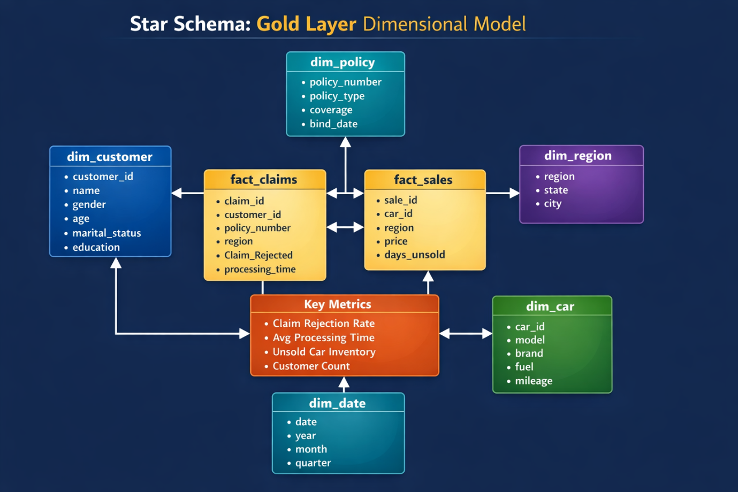

6. Final Statement
This dimensional model enables efficient and scalable analytics by organizing data into fact and dimension tables. It supports cross-functional business insights and serves as the foundation for dashboards and GenAI-driven applications.

